Week 5-Hands on : Microservices with API gateway
Creating Microservice for account:
- Implementing controller method for getting account details based on account number
- First creating the Account class
File name: Account.java
package com.cognizant.account.Model;
public class Account {
private String number;
private String type;
private double balance;
public Account(String number , String type , double balance){
this.number=number;
this.type=type;
this.balance=balance;
}
public String getNumber(){
return number;
}
public String getType(){
return type;
}
public double getBalance(){
return balance;
}
}
- Controller class for handling the request
File name: AccountController.java
package com.cognizant.account.Contoller;
import com.cognizant.account.Model.Account;
import org.springframework.http.ResponseEntity;
import org.springframework.web.bind.annotation.GetMapping;
import org.springframework.web.bind.annotation.PathVariable;
import org.springframework.web.bind.annotation.RequestMapping;
import org.springframework.web.bind.annotation.RestController;
@RestController
@RequestMapping("/accounts")
public class AccountController {
@GetMapping("{number}")
public Account getAccountDetails(@PathVariable String number){
return new Account(number , "savings" , 234344);
}
}

OUTPUT:
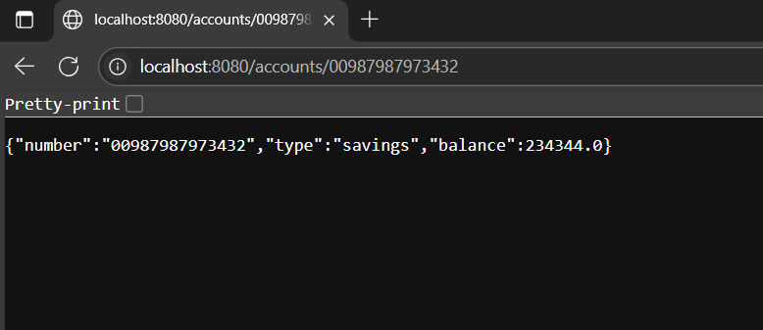

Creating Microservice for loan:
- Implementing controller method getting loan details based on account number
- First creating the Account class
File name: Account.java:
package com.cognizant.loan.Model;
public class Account {
private String number;
private String type;
private double loan;
private double emi;
private int tenure;
public Account(String number, String type, double loan, double emi, int tenure) {
this.number = number;
this.type = type;
this.loan = loan;
this.emi = emi;
this.tenure = tenure;
}
public String getNumber() {
return number;
}
public String getType() {
return type;
}
public double getLoan() {
return loan;
}
public double getEmi() {
return emi;
}
public int getTenure() {
return tenure;
}
}

- Controller class for handling the request
File name: LoanController.java
package com.cognizant.loan.Controller;
import com.cognizant.loan.Model.Account;
import org.springframework.web.bind.annotation.GetMapping;
import org.springframework.web.bind.annotation.PathVariable;
import org.springframework.web.bind.annotation.RequestMapping;
import org.springframework.web.bind.annotation.RestController;
@RestController
@RequestMapping("/loans")
public class LoanController {
@GetMapping("{number}")
public Account getLoan(@PathVariable String number){
return new Account(number , "car" , 40000 , 15000 , 18);
}
}

- Changing the server property to 8081 because we already have an Account service is already using the port 8080

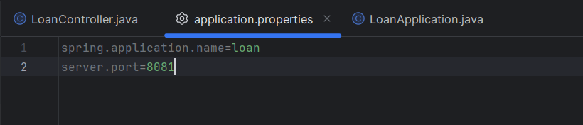

OUTPUT:
